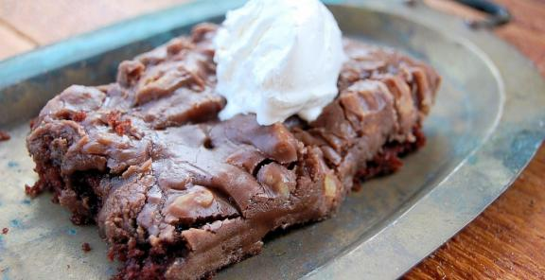

**Skillet Chocolate Sheet Cake**

Kitchen Belleicious

Feeds 8

**Ingredients**  
For the Cake:  
1 cup flour  
1/2 teaspoon baking soda  
1 cup sugar  
Dash of salt  
1/4 cup (1/2 stick) butter  
1/4 cup vegetable oil  
2 tablespoons cocoa powder  
1/2 cup water  
1/4 cup buttermilk  
1 egg  
1/2 teaspoon vanilla  
     
For the Topping:  
1/4 cup (1/2 stick) butter  
2 tablespoons cocoa  
3-4 tablespoons milk (as needed for consistency)  
1/2 cup pecans, chopped  
2 cups powdered sugar  
1/2 teaspoon vanilla

**Directions**

1. Preheat the oven to 350 degrees F. In a large bowl, whisk flour, baking soda, sugar and salt together and set aside.
2. In a 10-inch cast iron skillet, bring the butter, vegetable oil, cocoa powder and water to a boil. Remove it from the heat and whisk in the dry ingredients well. Mix in the buttermilk, egg and vanilla. Bake the skillet cake at 350 degrees F for about 15-20 minutes or until a toothpick comes out with just a few moist crumbs.
3. While the cake starts to cool, make the frosting. In a medium saucepan, bring the butter, cocoa, and milk to a boil. Remove them from heat and add the icing sugar, nuts and vanilla. Stir to combine. Pour over the warm cake and spread with a spatula.

http://www.kitchendaily.com/recipe/skillet-chocolate-sheet-cake